**Lesson 1: Theoretical Part**

**What is Cost Management?**

Cost Management is the process that establishes the policies, procedures, and documentation for planning, managing, expending, and controlling project costs. (PMBOK)

Estimate Costs

Determine Budget

Control Costs

**Estimate Costs**

Cost Types:

**Direct**

All the costs that are linked to the project’s activities directly like material costs that are subject to the variable quantities in the project.

**Indirect**

All the costs that are not linked with the project’s activities directly, like mobilization, office preparation, taxes, telephones.

**Tools and Techniques**

**Analogous Estimating**

* + Use data from **old project** for **same activity**
  + Activity should be **same quantity**
  + Used when we **don’t have a lot of information**
  + **Pros**: Low cost and Time
  + **Cons**: Lack of Accuracy

**Parametric Estimating**

* + Depends on **unit estimate**
  + Like square meter cost in construction
  + Used when we **know more information** about the project
  + Higher Accuracy

**Three-Point Estimating**

**Depend on PERT Technique:**

CO: Optimistic CP: Pessimistic CM: Most Likely

Triangular Distribution 

Peta Distribution

**Reserve Analysis**

In Project Management, Reserve Analysis is the process of **estimating the amount of money** that should be set aside to **cover unexpected costs**. This can be done by looking at past projects and estimating how much money was spent on unforeseen expenses

**Contingency Reserves**

* Known-Unknowns
* Accepted identified Risks which have response Strategies
* Can be % or fixed number
* Included in Cost Baseline
* Visited while executing
* Documented

**Management Reserves**

* Unknowns-Unknowns
* Unseen work inside scope
* Not part of Cost Baseline
* Part of Overall Project Cost Requirements
* When used it moves to Cost baseline through CR

**Estimate Cost: Output**

**Activity Cost Estimates**

* + Direct and Indirect Costs
  + Inflation influence
  + Contingency Reserves

**Basis of Estimates**

* + How estimate done
  + Assumptions and Constraints
  + Level of Accuracy

**Determine Budget**

**Determine Budget: Output**

**Cost Baseline**

* It is the Approved version of (Time Phased Project Budget)
* Used as basis of comparison

**Contingency Reserves**

**Cost Baseline**

**Work Package Cost Estimate**

Activity Contingency Reserves

Activity Cost Estimate

**Management Reserves**

**Project Budget**

**Project Funding Requirements**

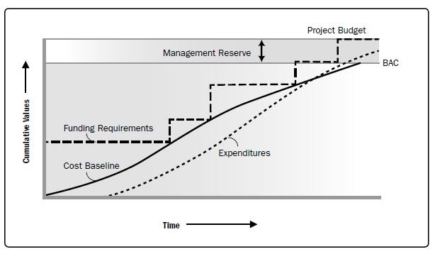

**Earned Value Formulas**

**Project Cost Management**

**Control Costs:**

* Check influences on Cost Baseline
* Manage Changes when happened
* Monitor expenses and compare it to funds
* Control cost performance and variance

**INPUTS**

1. Project management plan

2. Project funding requirements

3. Work performance data

4. Organizational process assets

**Tools & Techniques**

**1. Earned value management**

**2. Forecasting**

**3. To-complete performance index (TCPI)**

**4. Performance reviews**

5. Project management software

6. Reserve analysis

**Outputs**

1. Work performance information

2. Cost forecasts

3. Change requests

4. Project management plan updates

5. Project documents updates

6. Organizational process assets updates

**Tool and Techniques**

**Earned Value Management**

|  |  |
| --- | --- |
| Term | Definition |
| EV | Earn Value |
| AC | Actual Cost |
| PV | Planned Value |
| BAC = Budget | Budget at Completion |
| EAC | Estimate at Completion |
| ETC | Estimate to Completion |
| VAC | Variance at Completion |

***Indicator Formulas***

|  |  |
| --- | --- |
| Term | Definition |
| SV | Schedule Variance |
| CV | Cost Variance |
| SPI | Schedule Performance Index |
| CPI | Cost Performance Index |
| Budget of Remaining Work | **BAC – EV** |
| Remaining Funds | **BAC – AC** |

When both SPI and CPI are **greater than 1**, we call **Under Budget - Ahead of Schedule**

When both SPI and CPI are **between 0 and 1**, we call **Over Budget** - **Behind Schedule**

When SPI **greater than 1** and CPI **between 0 and 1**, we call **Over Budget** – **Ahead of Schedule**

When SPI **between 0 and 1** and CPI **greater than 1**, we call **Under Budget** – **Behind Schedule**

***The same with (SV and CV) – less use***

**Example:**

* Activity: Cutting the Grass
* Budget Cost: $1000
* Duration: 10 days

**After 5 days:**

* We spend $600
* We finished 40% of the Field
* What is SPI, CPI, CV, SV for this activity?

**Solve**:

**Forecasting**

***1st Scenario****: Continue as Planned*

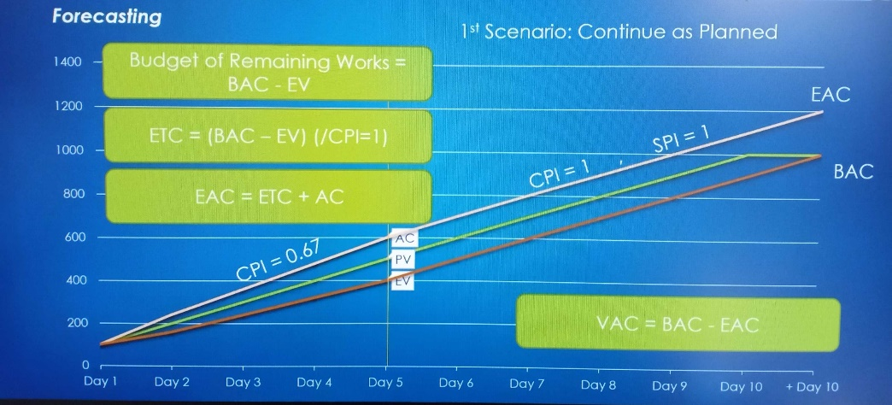

***2nd Scenario:*** *Consider Prev. CPI*

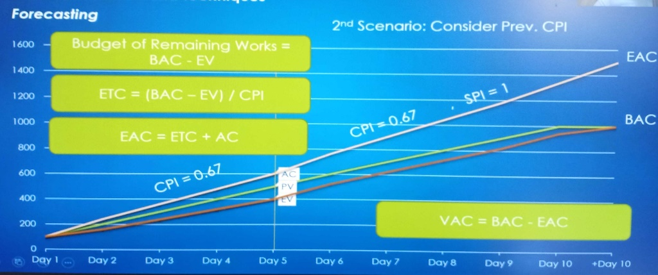

***3rd Scenario****: Consider Prev. CPI and SPI*

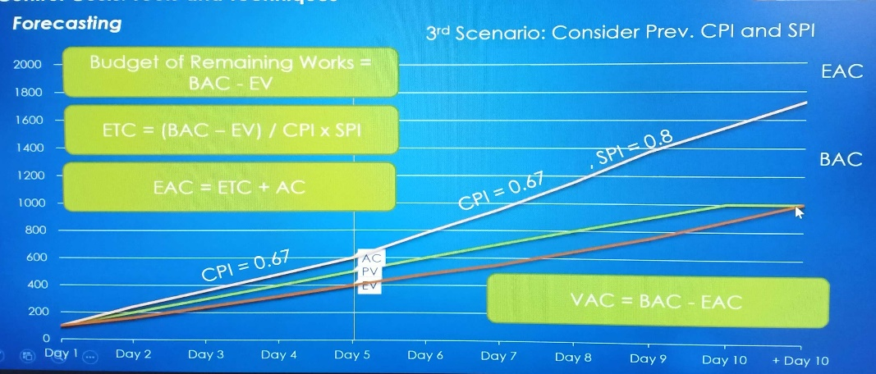

**3 Scenarios of Forecasting:**

**CPI = 1**

**ETC = EAC - AC**

**CPI = Current**

**CPI and SPI = Current**

**EAC = AC + (BAC – EV)**

**ETC = EAC - AC**

**EAC = BAC/CPI**

**ETC = EAC – AC =**

**EAC = AC +**

***Example (Previous):***

***1st Scenario:***

* ETC = BAC – EV = 600
* EAC = ETC + AC = 1200
* VAC = BAC – EAC = -200

***2nd Scenario:***

* ETC = EAC – AC = 900
* EAC = BAC/CPI = 1500
* VAC = BAC – EAC = -500

***3rd Scenario:***

* ETC = = 1125
* EAC = AC + =1725
* VAC = BAC – EAC = -725